**Seahaven Coastal Trail Walks**

**Monday 20th June 10.30-11.00am Telscombe Cliffs**

Meet at Smuggler’s Rest, Telscombe Cliffs and walk to The Peacehaven, Peacehaven. Enjoy a stroll along the cliffs, a relatively flat walk ideal for beginners - enjoy the coastal views and wildlife.

**Wednesday 22nd June 10-11.30am Peacehaven**

Meet at Rowe Avenue Surgery, Peacehaven for a healthy walk on the Coastal Trail with some steep slopes to get on and off the Undercliff path.

**Monday 27th June 1-2.30pm Newhaven**

Meet at Quayside Surgery, Newhaven and walk to West Beach. Look at some of the specialist coastal flora and fauna.

**Tuesday 28th June 10-12.00pm Peacehaven**

Meet at the bus stop adjacent Seaview Road (ID esuamgwa) on the Coastal Road for a walk along the cliffs looking for butterflies and flora and fauna.



**C4C**

**Come and enjoy a relaxed walk and meet people!**

**Contact Jessie on 01273 516032**

[**healthylifestyles@sussexcommunity.or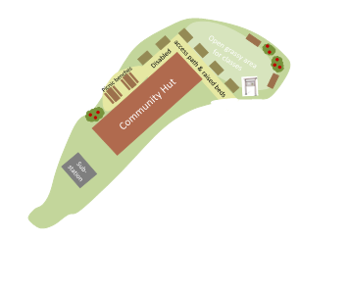g.uk**](mailto:healthylifestyles@sussexcommunity.or)

**www.seahavencoastaltrail.****org.uk**

